Tutorial Iceberg-Charts

Here is the most basic way of creating a chart with Iceberg Charts. Although more complex constructors are usually used to customize a chart, some basic constructors can help you get started very quickly.

ArrayList<DataPoint> values = **new** ArrayList<DataPoint>();

values.add(**new** DataPoint(5, 96));

values.add(**new** DataPoint(58, 43));

values.add(**new** DataPoint(101, 90));

values.add(**new** DataPoint(135, 67));

values.add(**new** DataPoint(150, 70));

XYChart lineChart = **new** XYChart(values, "My Easy Example");

JFrame frame = **new** JFrame();

frame.add(lineChart);

frame.setSize(700, 500);

frame.setVisible(**true**);

The chart you will see will look like this :

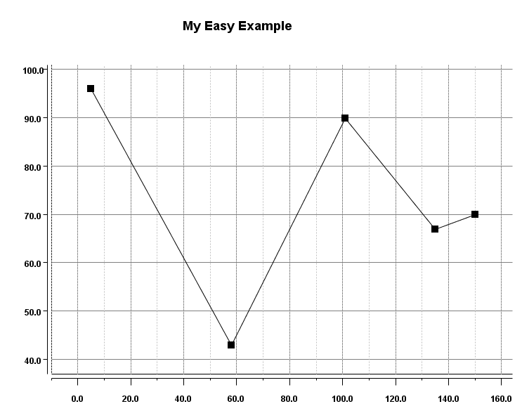

IcebergCharts automatically fits the data onto a chart with an x-axis and y-axis that have a scale which represents the data in a way which is easy on the eye.